Version 03
ZFI_RECEIPT_PARK
- Tax Code & Business Place remove.
- Correct Name “Excess Amount” as “Excess Basic Amount”. (Can we Add this Two field Excess Basic and Excess TDS below table)
- Create One more field i.e. “Credit TDS Amount” & Rename Credit Amount as “Credit Basic Amount”.
- Rename Mode of Payment “07 = Credit Note Basic” & add new one “08 = Credit Note TDS”.
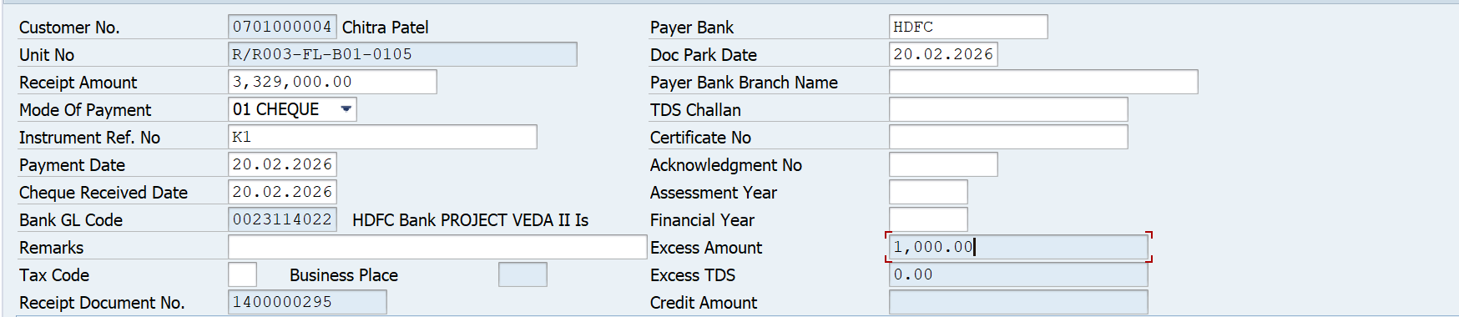
- BAPI - SD_SALESDOCUMENT_CREATE to be implemented at Excess Basic Amount & Excess TDS Amount, when any value exists in both fields, credit notes will be created with reference to Booking Number (Pass KUNNR into VBAK & get VBELN).
- If Excess Basic Amount is GT 0, Credit Note BAPI will be trigger.
MATNR = “Excess Basic Amount”, KSCHL (Condition Type) = “ZXCR” & KDKG1 (Condition Group 1) = “Z1”.
- If Excess TDS Amount is GT 0, Credit Note BAPI will be trigger.
MATNR = “Excess TDS Amount”, KSCHL (Condition Type) = “ZXCT” & KDKG1 (Condition Group 1) = “Z1”.

BAPI triggers point when Value against Excess Basic and Excess TDS line exist. (Refer Point 2)

- Credit Basic Amount Logic: Pass KUNNR into CUST_NO & get sum of COLLECTION_AMOUNT where KSCHL = “ZXCR” minus Sum of COLLECTION_AMOUNT where MODE_OF_PAYMENT = “Credit Note Basic” & KSCHL = “ZBSP, JOCG & JOSG”.
- Credit TDS Amount Logic: Pass KUNNR into CUST_NO & get sum of COLLECTION_AMOUNT where KSCHL = “ZXCT” minus Sum of COLLECTION_AMOUNT where MODE_OF_PAYMENT = “Credit Note TDS” & KSCHL = “ZTDS”.
- Credit Basic amount will be adjusted when Mode of Payment = “07 = Credit Note Basic” based on FIFO basis against Billing document “ZBSP, JOCG & JOSG” only.
- Credit TDS amount will be adjusted when Mode of Payment = “08 = Credit Note TDS” based on FIFO basis against Billing document “ZTDS” only.

